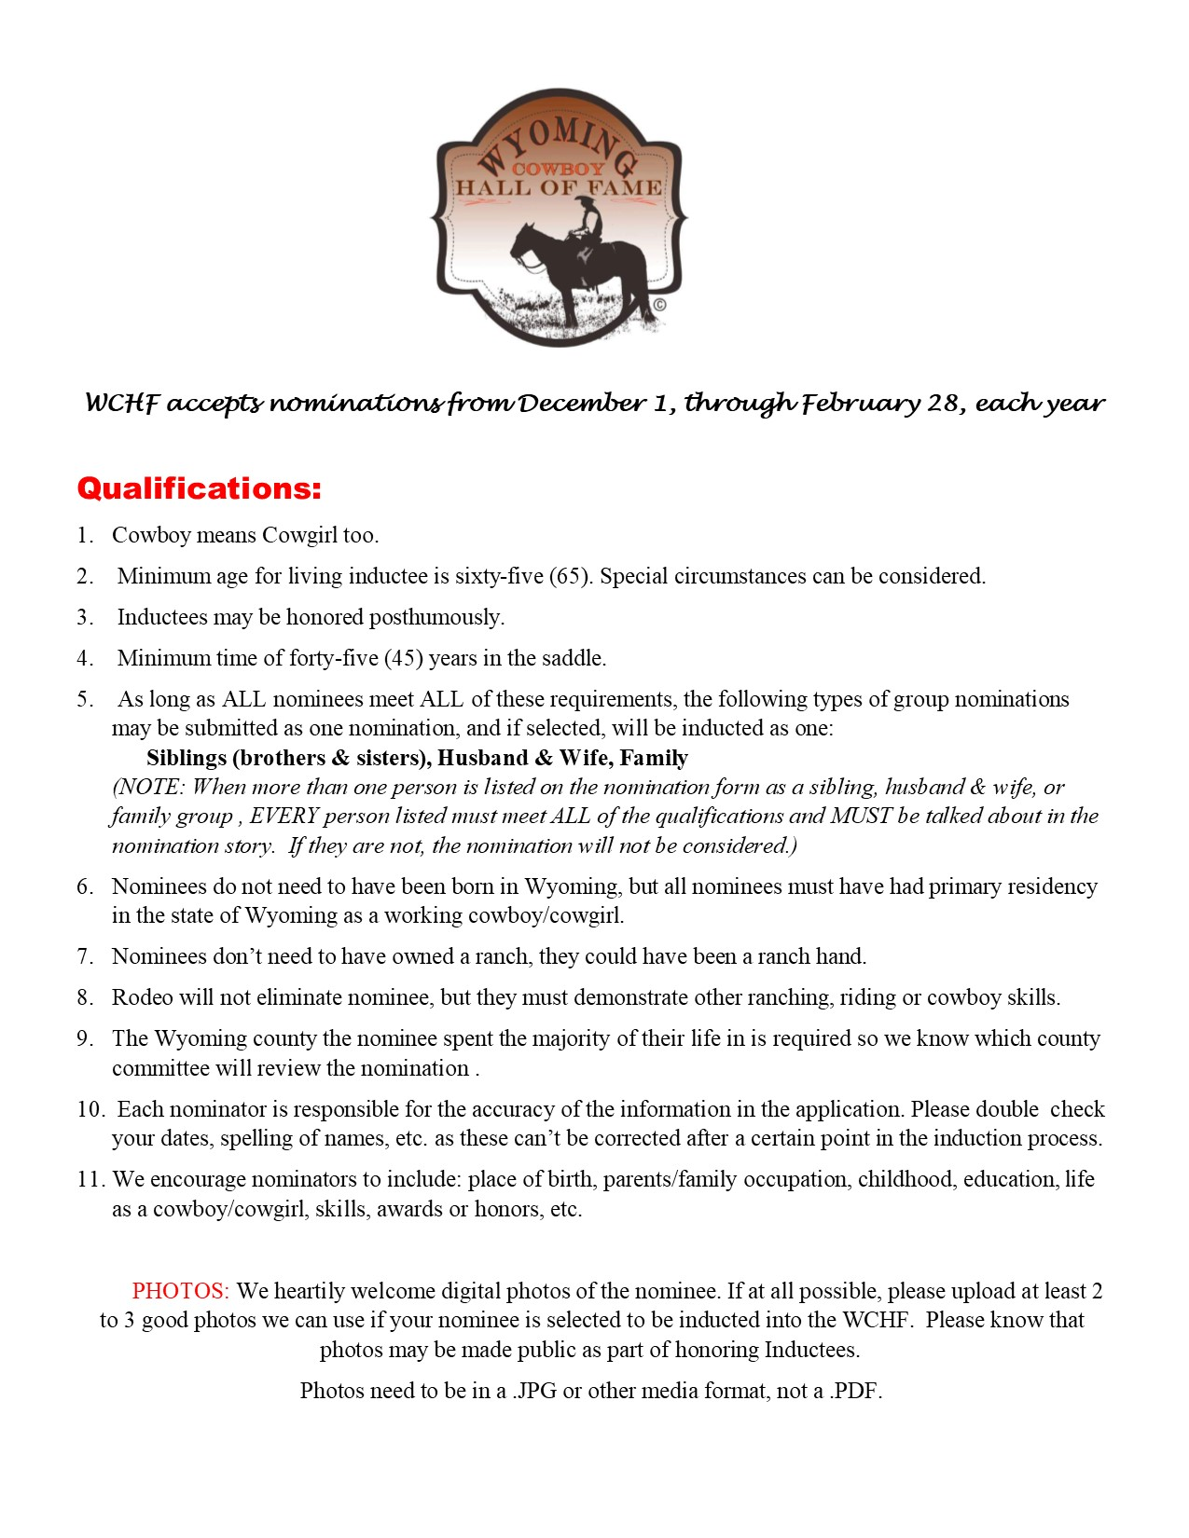

Frequently Asked Questions

Q. Can anyone submit a nomination?
A. Yes, anyone can submit a nomination. Our hope, our goal is to make the most of the wealth of local knowledge across the state about our significant Cowboy culture.

Q. How do I submit an application for a nominee?
A. Nomination applications will be available on the Wyoming Cowboy Hall of Fame website from Dec 1 through Feb 28, of each year. Download the word document to your computer, fill in the nomination form completely while saving your work frequently, then attach your completed nomination form to an email to wchfassistant@gmail.com with the Nominee’s name and county in the subject line of the email. Also attach 2-3 photos in jpg or tiff formats, NO PDF photos.

Q. Is there any fee to submit an application for a nominee?
A. No, but you can choose to make a donation, via PayPal, when you submit your application to help defer some of the costs involved with processing your nomination application and investigating your nominee.

Q. What happens to my application after I submit it?
A. Completed nominations will be sorted and sent to the regions in which the nominee resided in most of their cowboy/cowgirl life. Local leaders on the Regional Committees will meet and review the nominations of potential honorees in their region in March and April. After investigating the nominations, the Regional Committees will identify nominees they wish to recognize and forward their recommendations to the WCHF Board to consider. The WCHF Board will review the recommendations, and vote on the nominees (in May) that will be inducted that year at both the local and state level. The regional induction is held the 3rd weekend of September to match up with Wyoming Cowboy and Cowgirl Legacy Week.

Q. Do the Regional Committees and the WCHF Board only select 1 nominee to be inducted each year?
A. Both the WCHF Board and the Regional Committees may choose the number of inductees to be honored with no minimum or maximum set.

Q. If the person I nominate isn’t chosen as an inductee, do I need to submit another application the following year for them to be considered?
A. No, all correctly completed nomination forms will be kept in a pool for future consideration.

Q. How will I know if the person I nominated was selected to be inducted?
A. The nominator will be notified and all inductees to the Wyoming Cowboy Hall of Fame will be publicized state-wide.

Q. How can I help the Cowboy Hall of Fame?
A. There are several ways you can help the Cowboy Hall of Fame. First of all, you can go to the Support Page on the website and choose the level of support you’d like to send. Secondly, you can serve as a member of your regional committee, please contact KayCee (WCHF Executive Director) if you are interested in doing so, 307-710-8646.

Nominee Information

Name:
Nickname, if any:
Phone (Best contact number for nominee or nominee’s family):
Address (For possible induction notification):
Date of Birth:
Date of Death (if applicable):
Hometown:
Wyoming County nominee spent the majority of their life in:
Years of Cowboy Experience:
Parents (if known):
Ranch(es) names where nominee worked:
Family occupation (if known):

Nominee’s Story: (The WCHF would like you to share any of the following virtues to help us better understand what made the nominee a cowboy: How they made a living as a cowboy, time spent working horseback (working horseback, not rodeoing), did they work cattle, sheep, or horses – could they doctor a sick animal, could they make a saddle horse, were they a good neighbor, their job at brandings, their character attributes that makes them a cowboy.) Please limit the story to 2 pages, with an additional 1-2 pages for each additional family member being inducted on one nomination. Pages can be added below this page by clicking on Insert above in the toolbar and then click on Pages to add additional pages.

Nominator’s Information

Name:

Relationship to the Nominee:

Address:

City:

Wyoming County:

State:

Zip Code:

Email (Verify this is typed correctly as we will email you to let you know your nomination has been received):

Phone (Best contact number for nominator):

Best Person to Contact About Nomination (if not the person making the nomination):

Thank you for nominating your favorite working cowboy or cowgirl!

Please verify that all of your work has been saved in the above form before attaching and sending in an email.

Don’t forget to attach 2-3 photos in jpg or tiff formats, to the same email as the nomination form, before sending to wchfassistant@gmail.com.

If you have questions about this form, please contact KayCee at 307-710-8646 or email: wchfassistant@gmail.com.

